Homework 2
Created by – Tushar Ahuja
NOTE:- In Assignment 1, I used Python code to create tables and insert data by connecting to the host and MySQL server. However, in this assignment, I will use MySQL Workbench and the Table Data Import Wizard for table creation and data insertion. Additionally, I will be removing empty cells and rows from the time_slot_id (time_slot.csv) column for better reporting and analysis.
The reason for removing these empty cells or null values is to ensure data integrity and consistency. Having null or missing values in the time_slot_id column could lead to incomplete or incorrect data when analyzing time slot assignments, making it harder to draw accurate conclusions or perform meaningful analysis. By eliminating these gaps, we ensure that all entries are associated with a valid time slot, which leads to more reliable reporting and clearer insights.
Part 1: Adding More Tables and Populating Data
- Creating time_slot table and inserting data
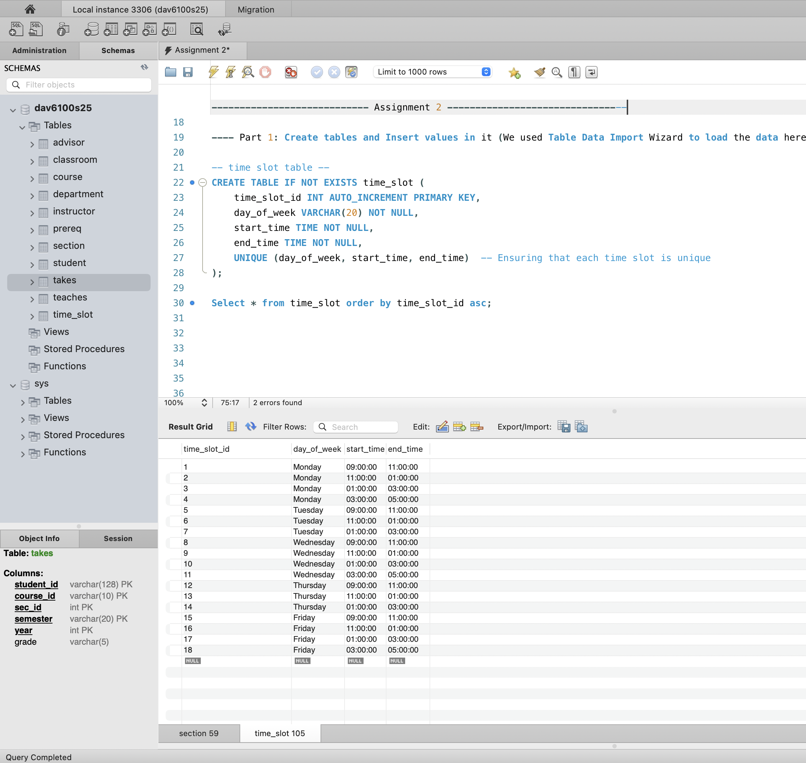
- Creating section table and inserting data
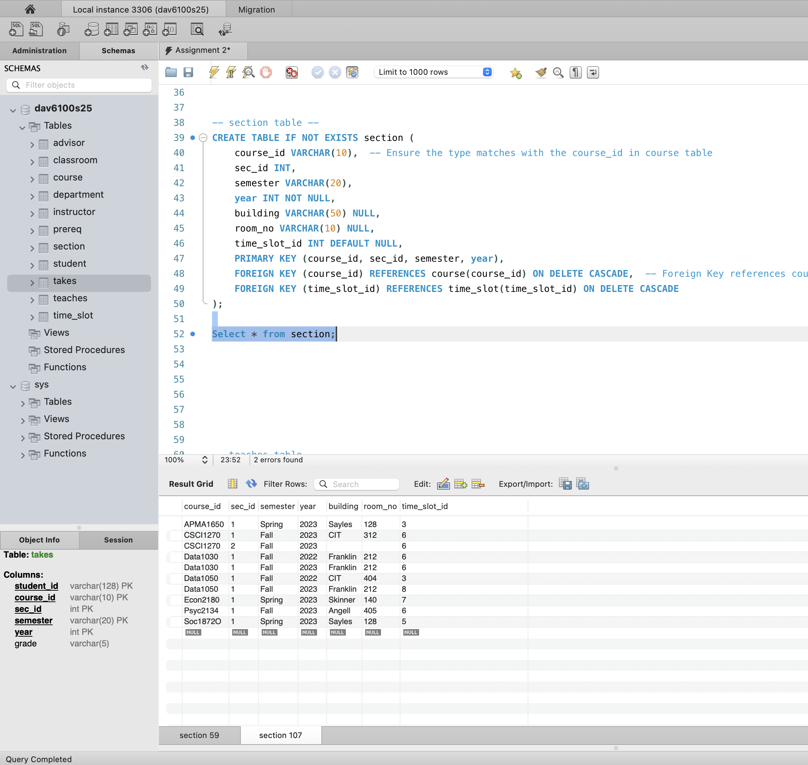

- Creating teaches table and inserting data
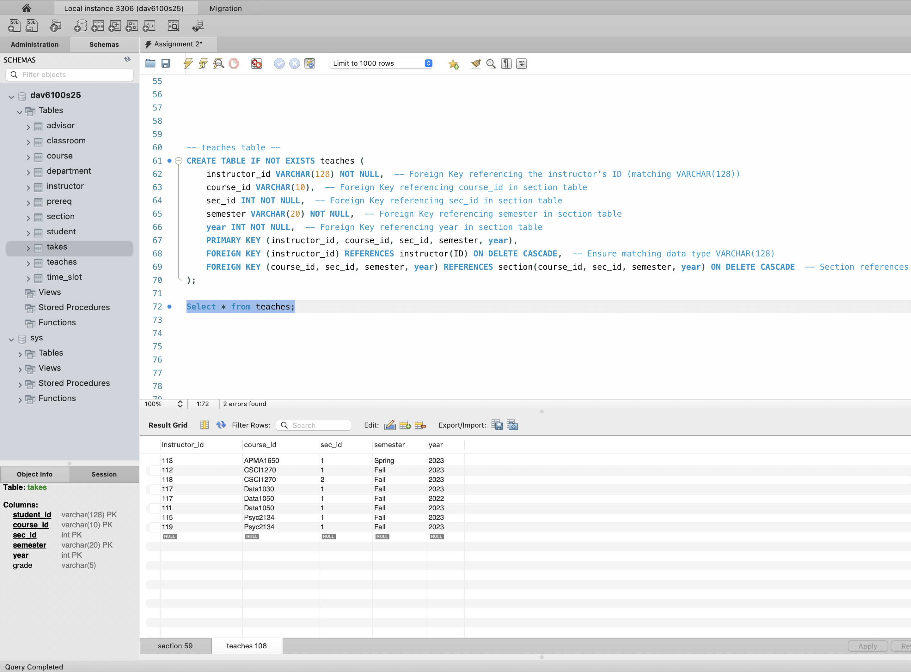
- Creating takes table and inserting data
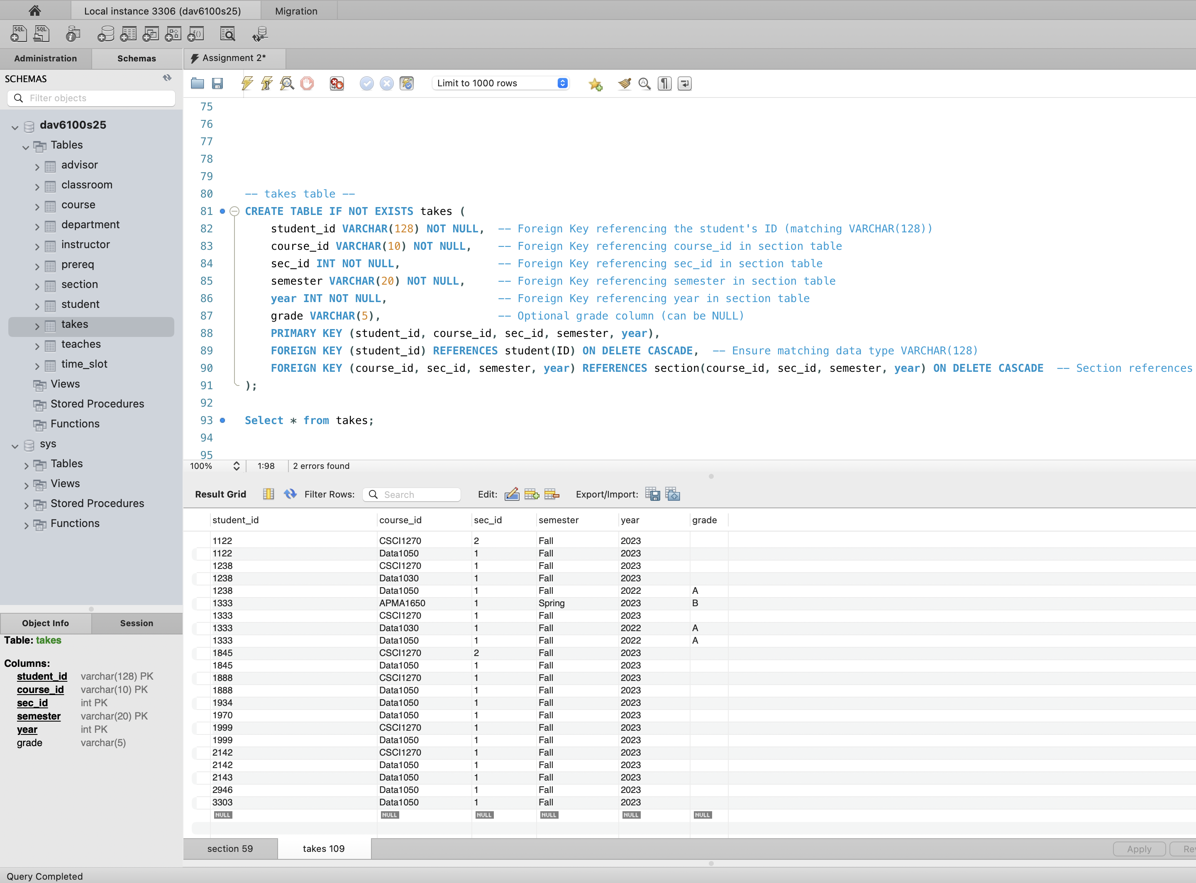

Part 2: Writing Queries According to Prompts
Question 1: Find the id, title, and section_id of all the courses being taught in Fall 2023.
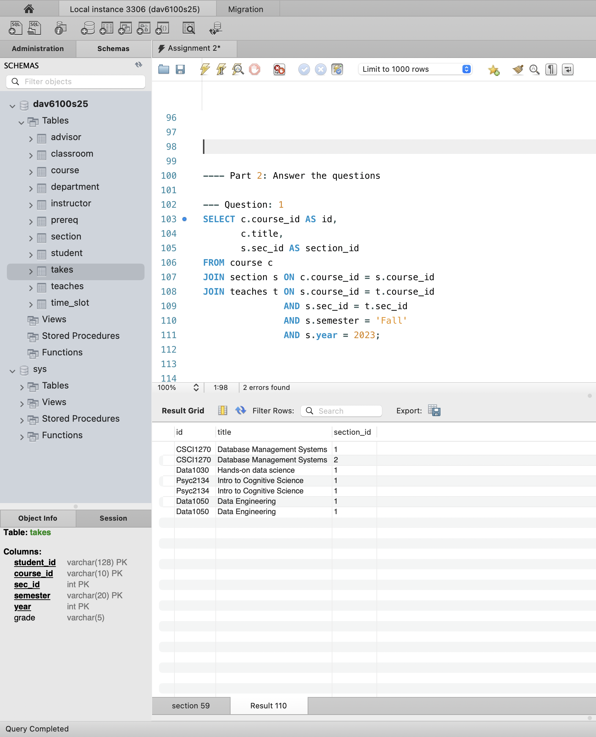

Question 2: Find the id, title, section_id, and instructor_name of all the courses being taught in Fall 2023.
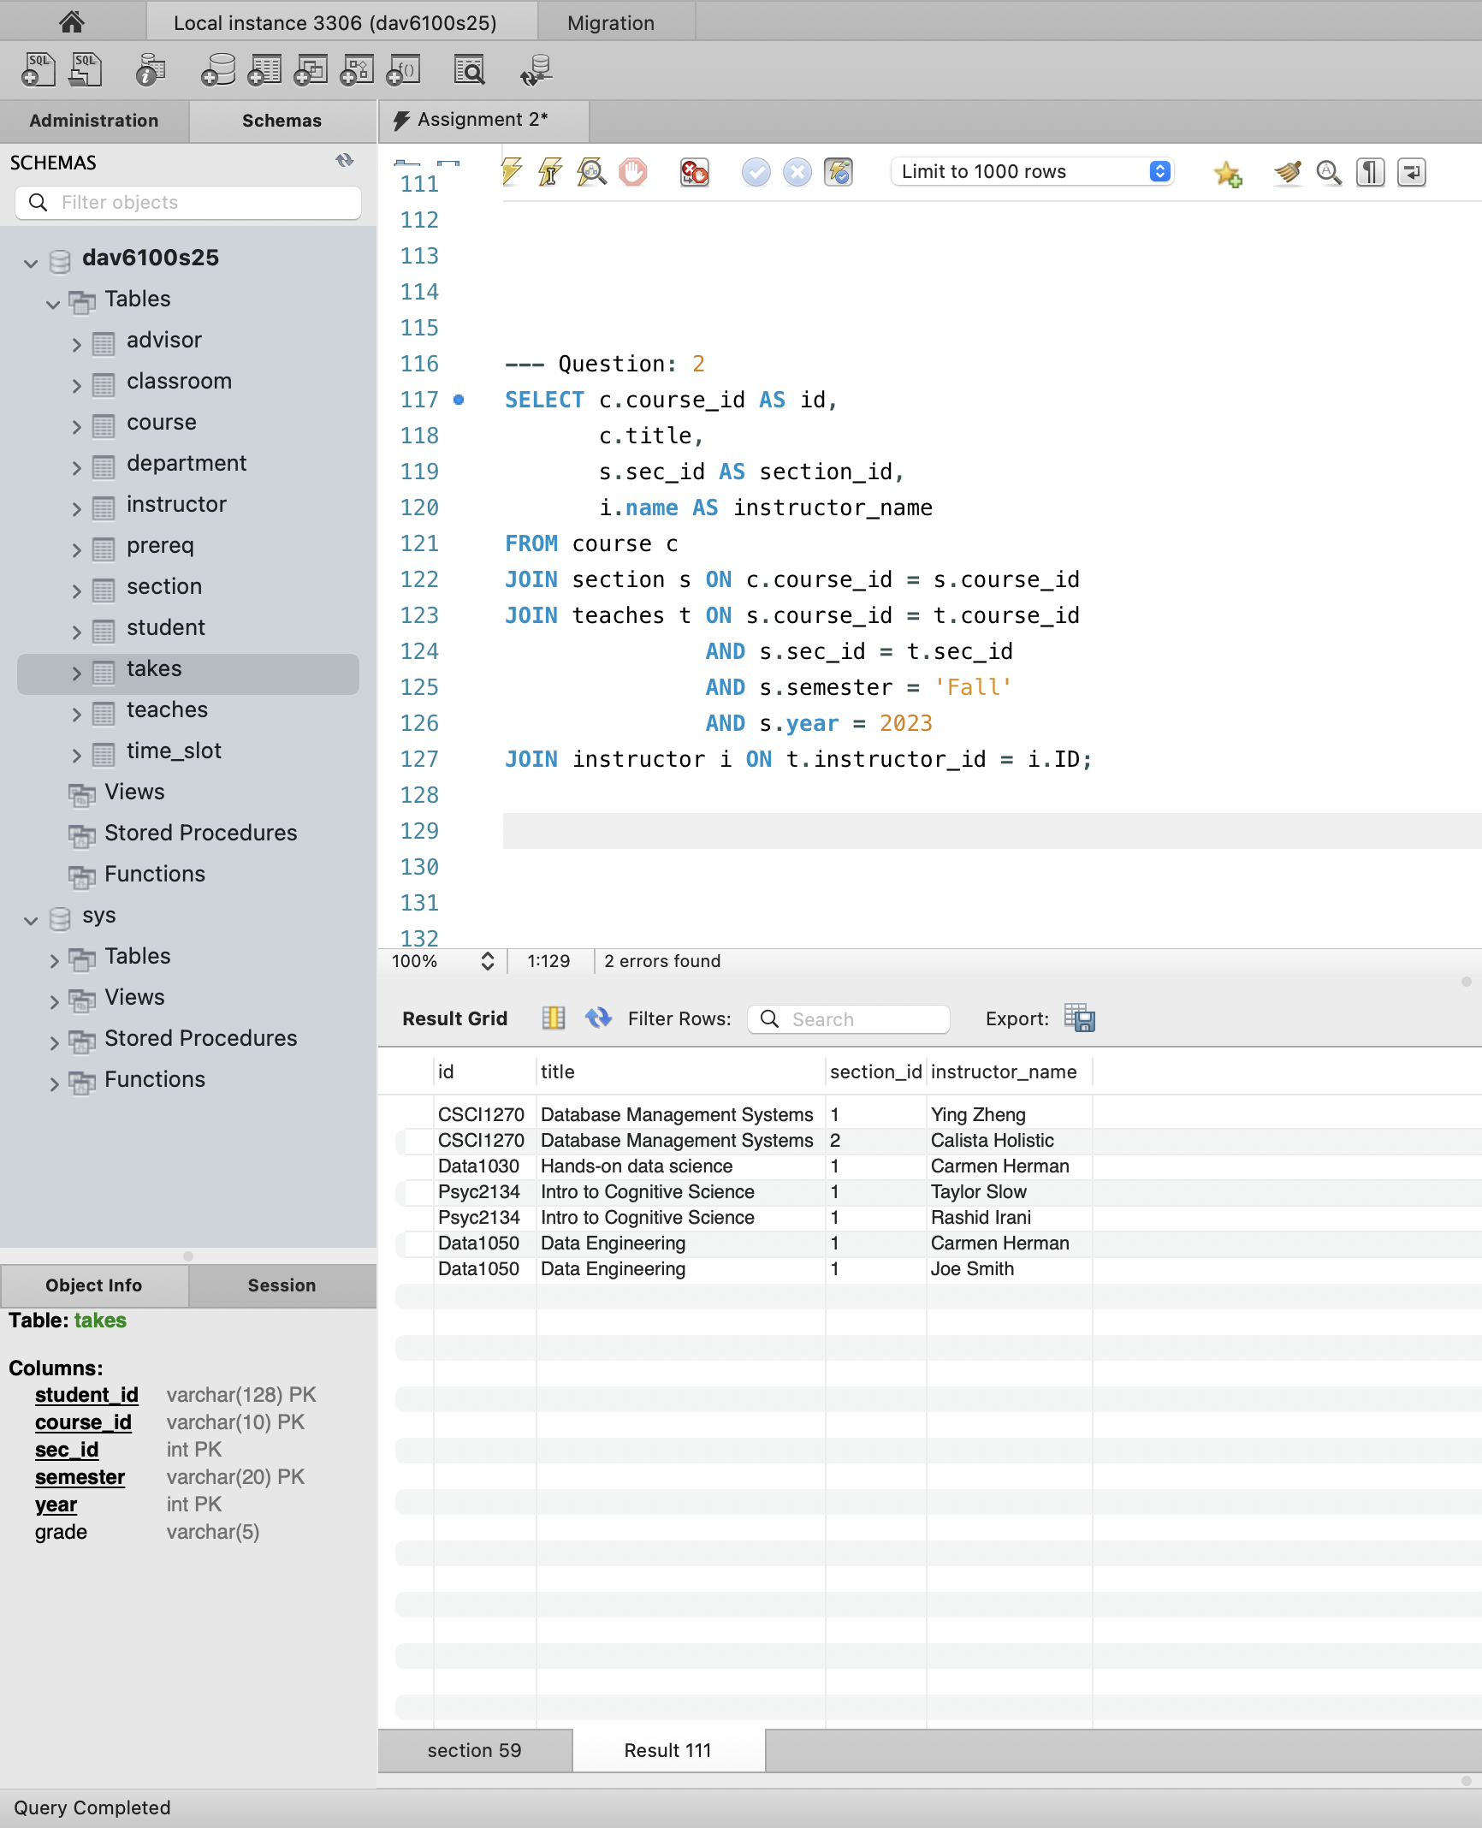
Question 3: Write an SQL instruction to change (i.e., update) the time_slot_id of all courses where it is 6 to 2. You may not delete these and insert new ones; use the UPDATE command.
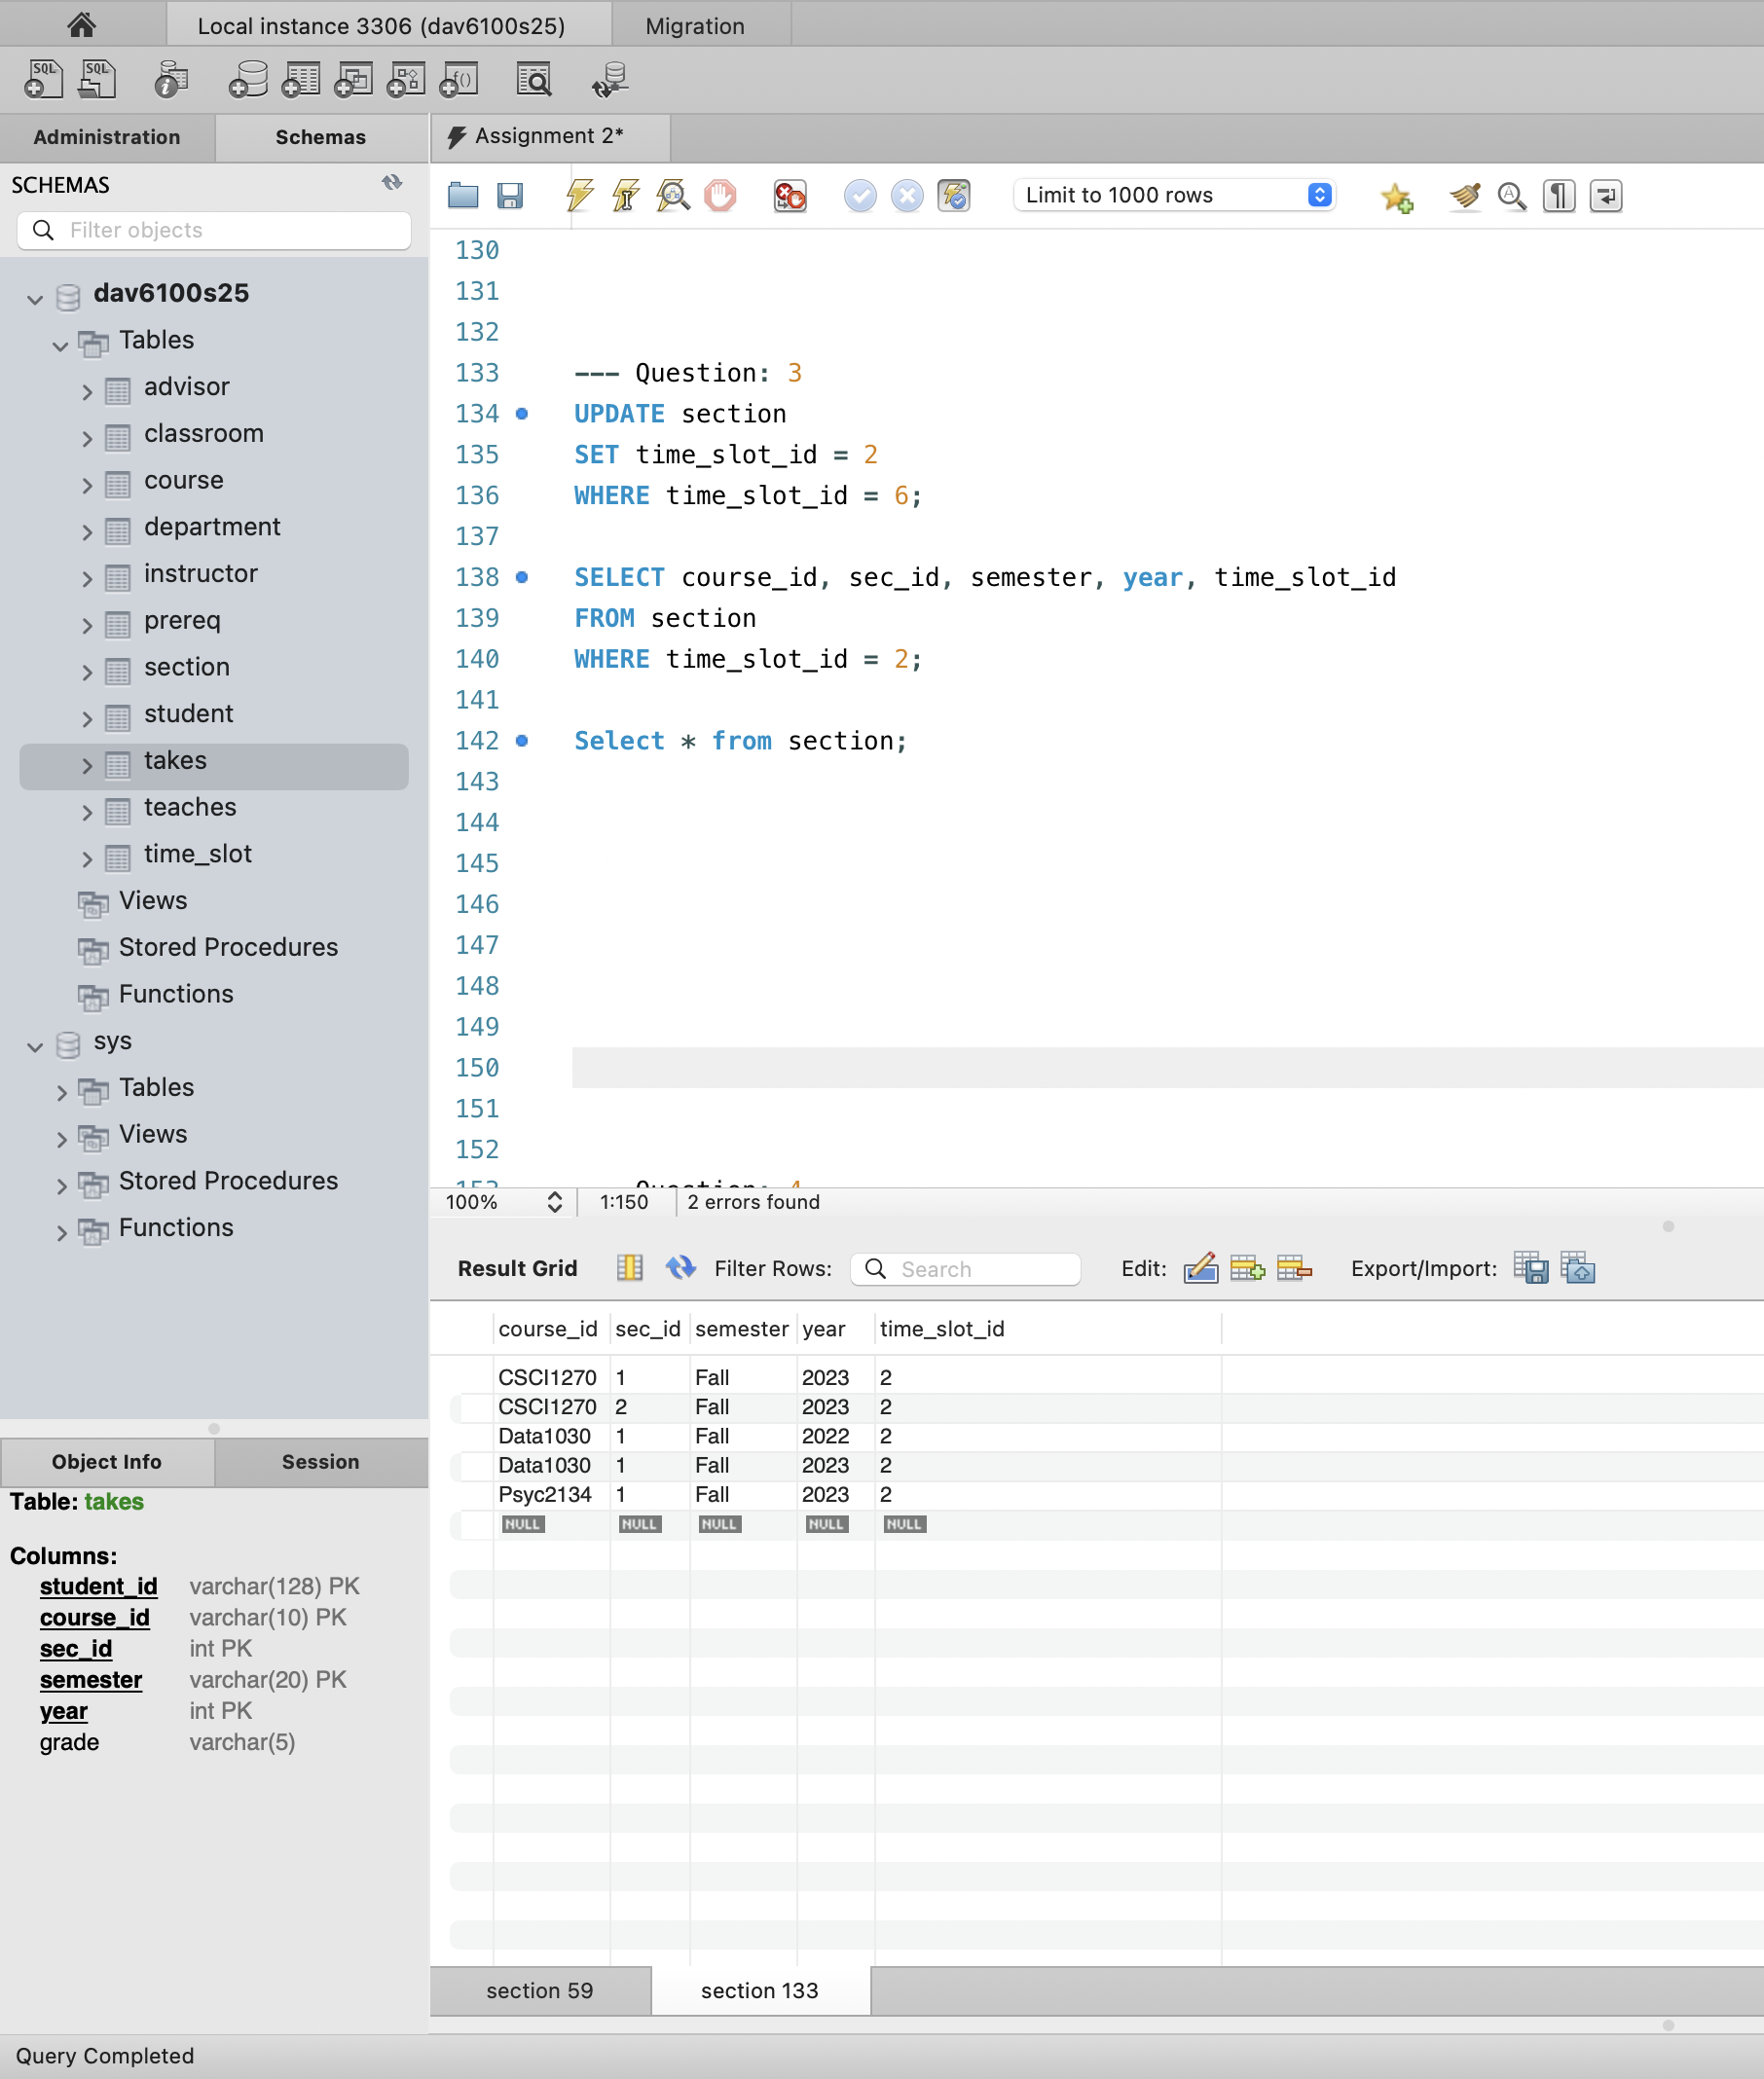

Question 4: Find the course_id, title, section, and start time of all courses taught in Fall 2022.
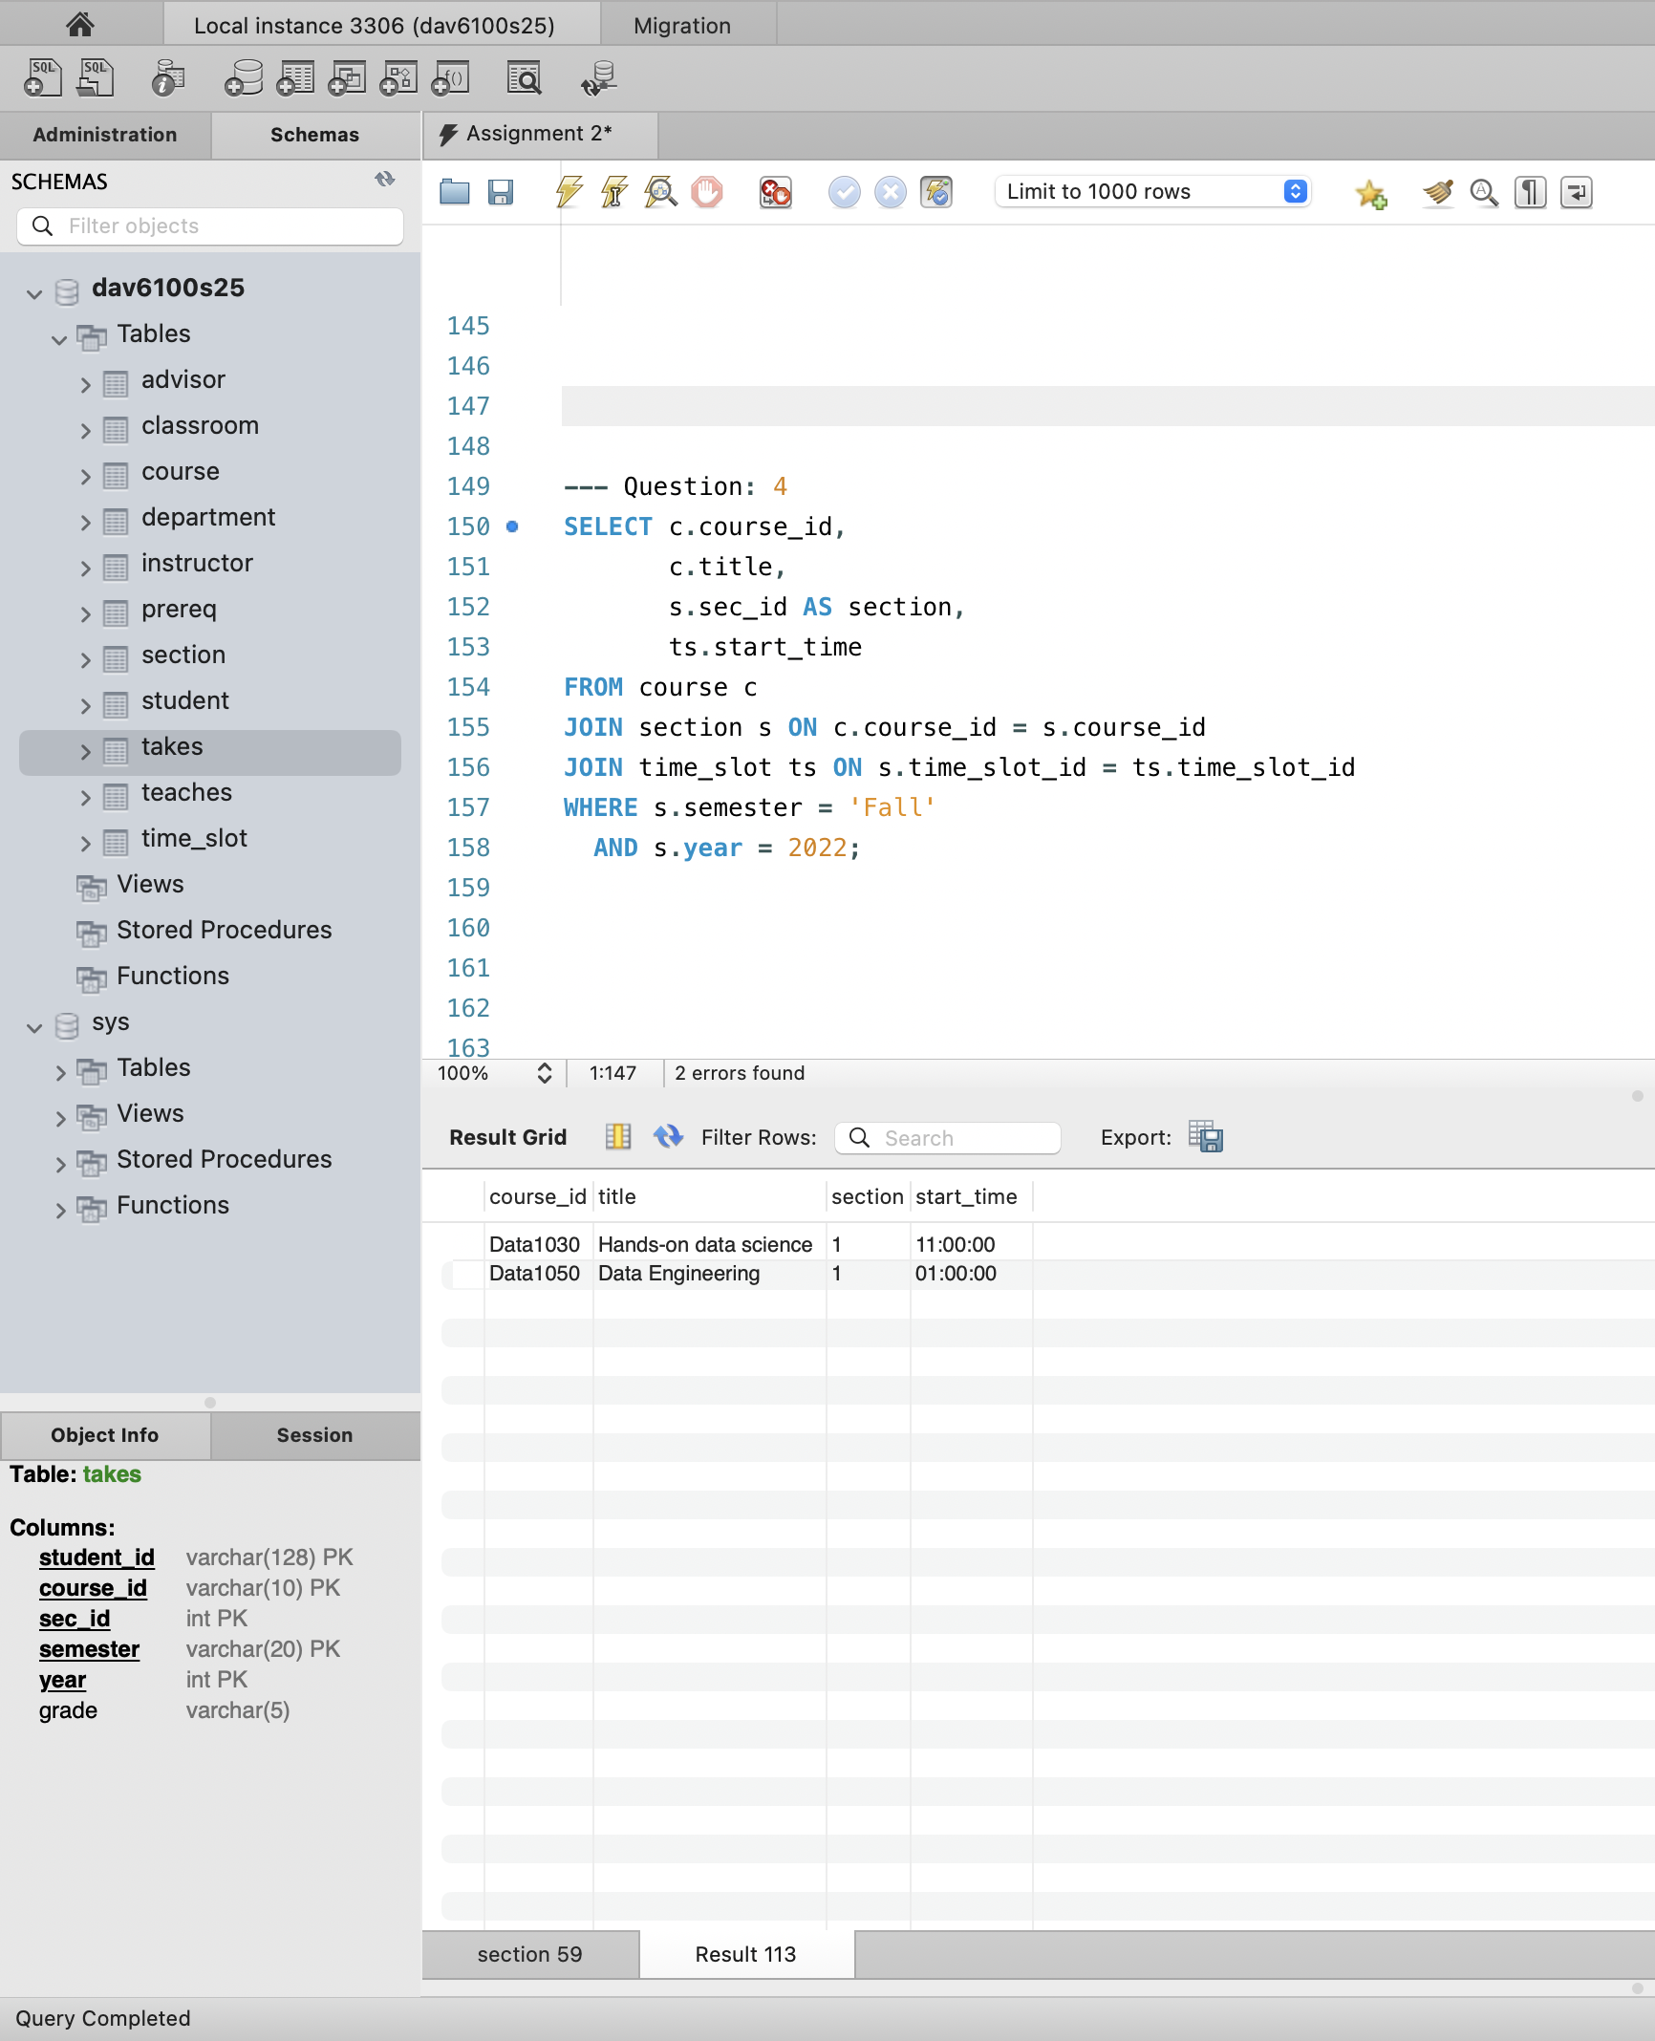

Question 5: Write an SQL instruction so that all students with IDs 1238 and 1333 who have a NULL grade in any course have their grade changed to 'A'.
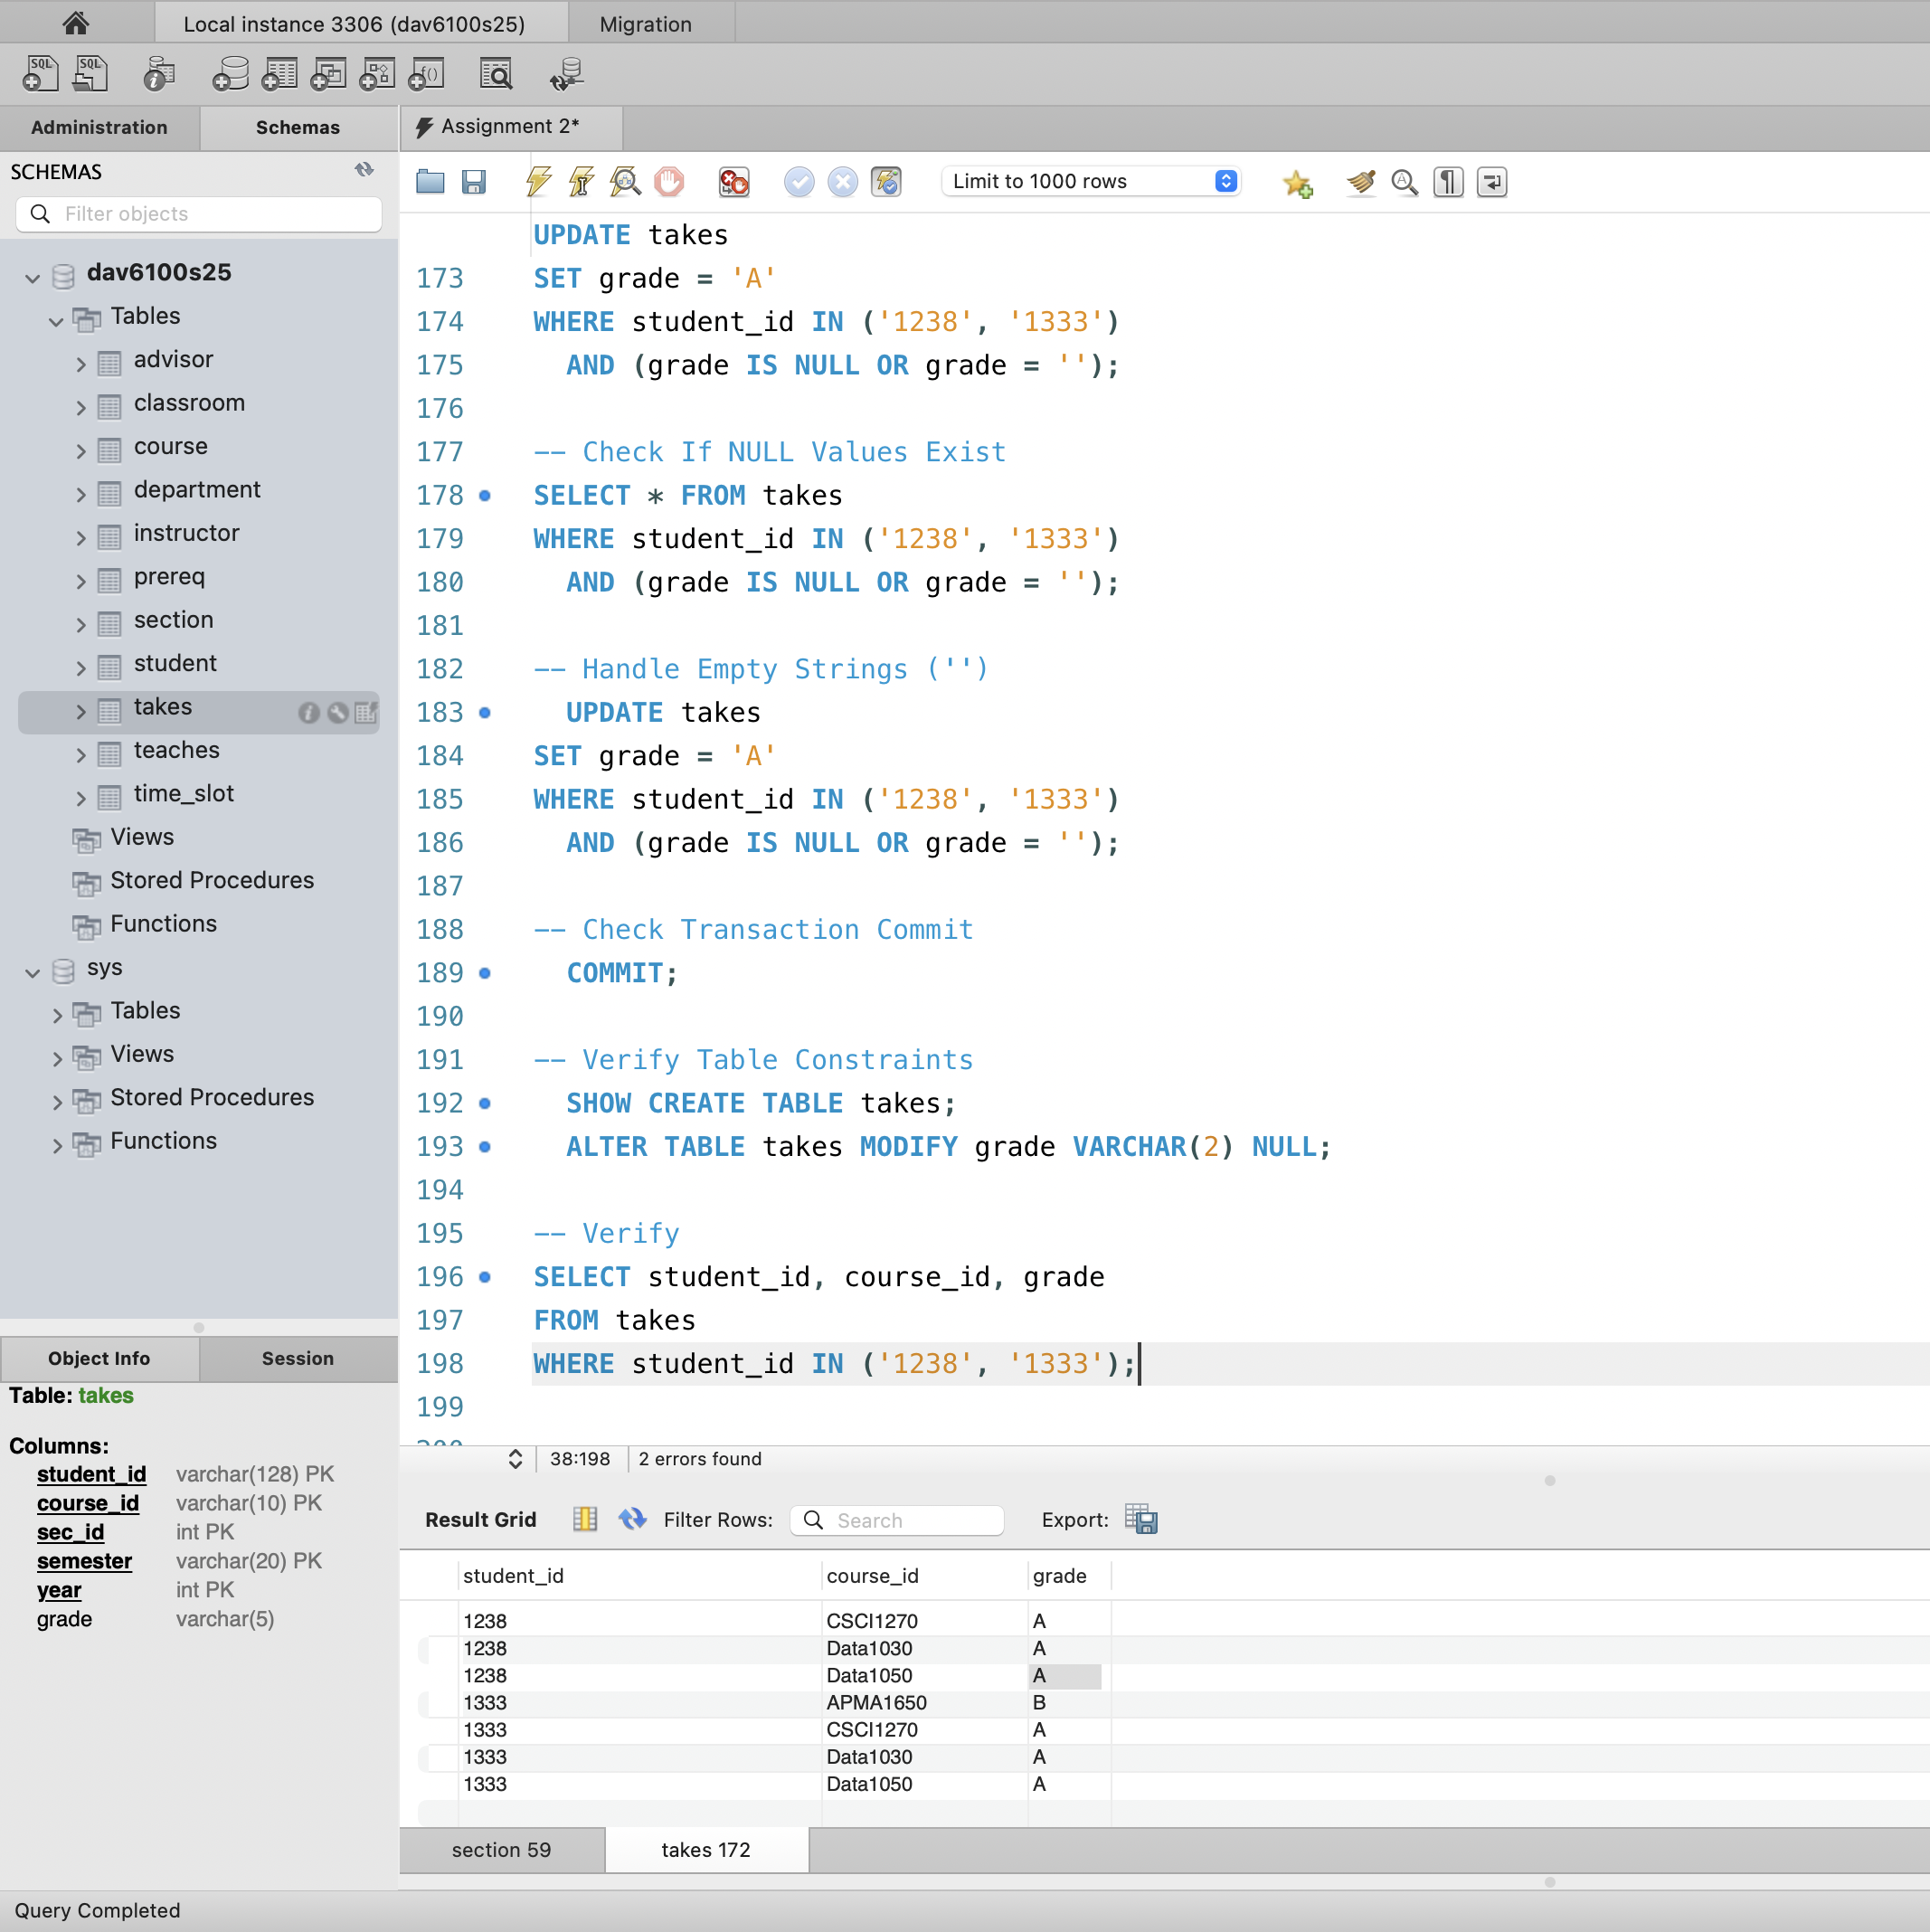

Since '1333', 'APMA1650', 'B' has a grade of 'B', it doesn’t meet the condition grade IS NULL and, therefore, is not updated.
Question 6: After executing the instruction in question 5, write a query to appropriately update the tot_credit for those students (i.e., increment it by the credits assigned to those courses where the grade was changed).

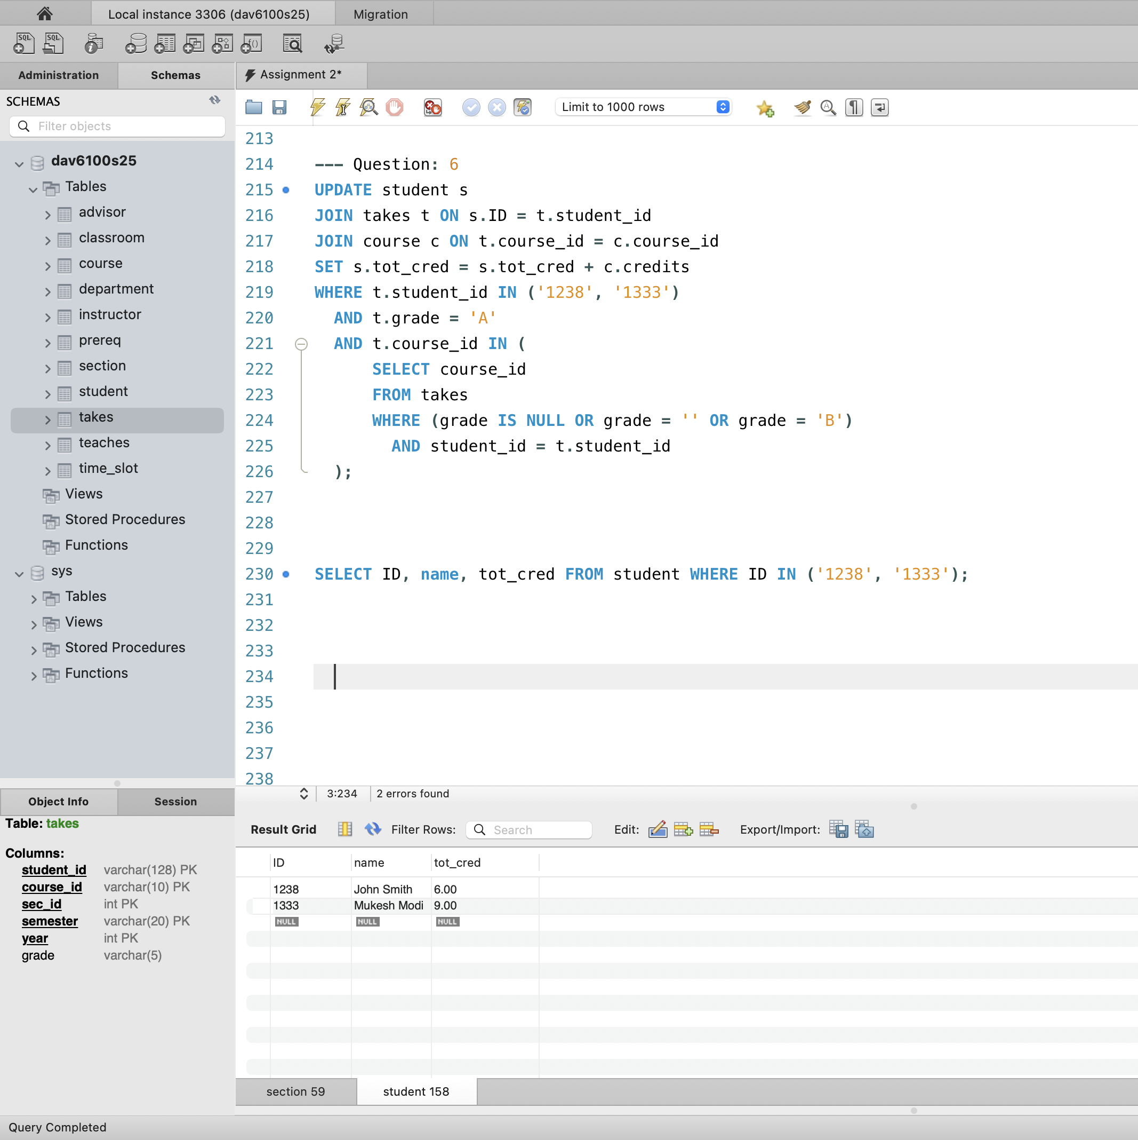

Question 7: After executing the instructions for questions 4 and 5, write a query to return the ID and name of the students who have the most credits.
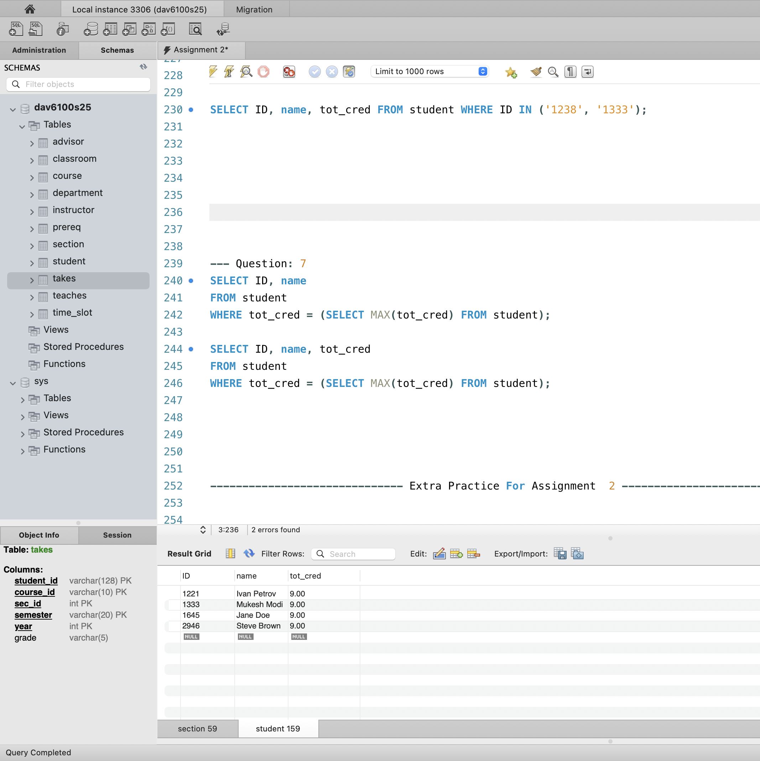

Conclusion:-

In this assignment, I followed a structured approach to create tables and load data using MySQL Workbench instead of Python. Below are the steps I followed to complete this task:
1. Table Creation Using MySQL Workbench
- First, I created the necessary tables by defining their schema in MySQL Workbench. The table creation process involved specifying the appropriate data types for each attribute, setting primary keys, and establishing foreign key relationships between tables, as required by the schema.
- MySQL Workbench allows the use of SQL Editor to execute SQL queries directly, so I wrote the CREATE TABLE statements for each table, ensuring that the foreign keys and primary keys were correctly defined.
- Each table was created based on the provided schema, with the necessary constraints for better data integrity.
2. Using Table Data Import Wizard
- After creating the tables, I used the Table Data Import Wizard feature in MySQL Workbench to load the data from the CSV files (such as time_slot.csv, section.csv, etc.) directly into the corresponding tables.
- To do this:
  - I navigated to the table where I wanted to import data.
  - Right-clicked on the table name and selected Table Data Import Wizard.
  - In the wizard, I selected the respective CSV file (e.g., time_slot.csv) and mapped the columns from the CSV file to the appropriate fields in the table.
  - The wizard automatically detected the column names and the data format, ensuring correct alignment between the CSV file and the table schema.
  - I proceeded with the import and reviewed the data to ensure that it was correctly loaded into the table.
3. Handling Missing or Empty Values
- While loading the data, I noticed that some rows had empty values (like NULL or NaN) in certain columns.
- For better reporting and analysis, I decided to remove empty cells or rows from the time_slot_id column before inserting the data. The reason behind this decision was that empty values in such critical columns can distort relationships between tables, particularly when these columns are used as foreign keys in other tables (like section table referencing time_slot_id). Removing these values helped ensure:
  - Data integrity: Avoided broken references and inconsistencies in the relationships between tables.
  - Accurate reporting: Ensured that any queries or reports derived from the data would not face issues with missing references.
  - Improved Analysis: Cleaned data allows for more accurate analysis since NULL values could potentially skew results or cause errors in calculations or data visualizations.
4. Data Review and Validation
- After the data was imported into the tables, I reviewed it in MySQL Workbench to ensure everything was correct.
- I performed some basic queries to check the integrity of the data and verify that it was properly inserted.
- This validation step helped ensure that all relationships (foreign key constraints) were correctly established and the data aligned with the expected structure.
5. Final Commit
- Once the data was successfully imported and validated, I performed the final commits within MySQL Workbench to make sure all changes were saved and persisted in the database.
By using MySQL Workbench and the Table Data Import Wizard, I simplified the process of creating tables and importing large datasets. This method was more efficient than writing custom code for each data insertion, providing an easy and reliable way to manage the database structure and data import.

